================================================================================
CAR PRICE PREDICTION PROJECT
================================================================================

Dataset Loaded Successfully!

First Five Rows

Car_Name Year Selling_Price Present_Price Driven_kms Fuel_Type \
0 ritz 2014 3.35 5.59 27000 Petrol
1 sx4 2013 4.75 9.54 43000 Diesel
2 ciaz 2017 7.25 9.85 6900 Petrol
3 wagon r 2011 2.85 4.15 5200 Petrol
4 swift 2014 4.60 6.87 42450 Diesel

Selling_type Transmission Owner
0 Dealer Manual 0
1 Dealer Manual 0
2 Dealer Manual 0
3 Dealer Manual 0
4 Dealer Manual 0

Dataset Shape : (301, 9)

Columns

['Car_Name', 'Year', 'Selling_Price', 'Present_Price', 'Driven_kms', 'Fuel_Type', 'Selling_type', 'Transmission', 'Owner']

Information

<class 'pandas.core.frame.DataFrame'>
RangeIndex: 301 entries, 0 to 300
Data columns (total 9 columns):
# Column Non-Null Count Dtype
--- ------ -------------- -----
0 Car_Name 301 non-null object
1 Year 301 non-null int64
2 Selling_Price 301 non-null float64
3 Present_Price 301 non-null float64
4 Driven_kms 301 non-null int64
5 Fuel_Type 301 non-null object
6 Selling_type 301 non-null object
7 Transmission 301 non-null object
8 Owner 301 non-null int64
dtypes: float64(2), int64(3), object(4)
memory usage: 21.3+ KB
None

Missing Values

Car_Name 0
Year 0
Selling_Price 0
Present_Price 0
Driven_kms 0
Fuel_Type 0
Selling_type 0
Transmission 0
Owner 0
dtype: int64

Duplicate Rows : 2

New Dataset Shape : (299, 9)

Statistical Summary

Year Selling_Price Present_Price Driven_kms Owner \
count 299.000000 299.000000 299.000000 299.000000 299.000000
mean 2013.615385 4.589632 7.541037 36916.752508 0.043478
std 2.896868 4.984240 8.566332 39015.170352 0.248720
min 2003.000000 0.100000 0.320000 500.000000 0.000000
25% 2012.000000 0.850000 1.200000 15000.000000 0.000000
50% 2014.000000 3.510000 6.100000 32000.000000 0.000000
75% 2016.000000 6.000000 9.840000 48883.500000 0.000000
max 2018.000000 35.000000 92.600000 500000.000000 3.000000

Car_Age
count 299.000000
mean 11.384615
std 2.896868
min 7.000000
25% 9.000000
50% 11.000000
75% 13.000000
max 22.000000
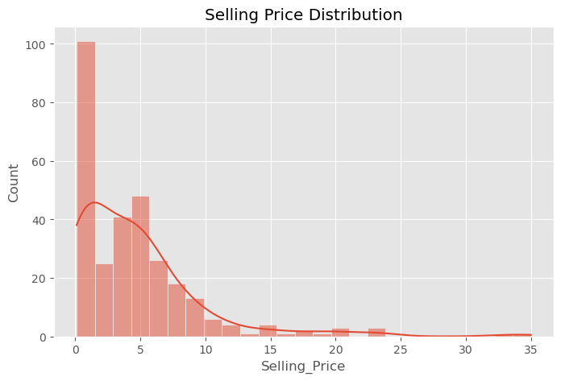
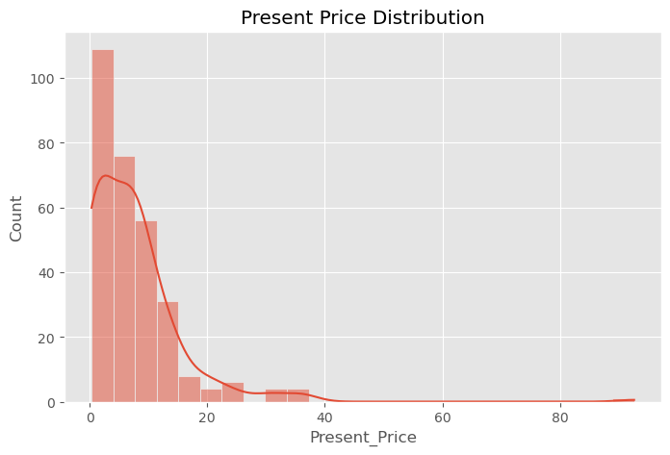
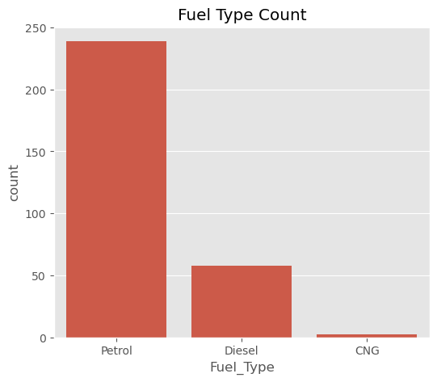
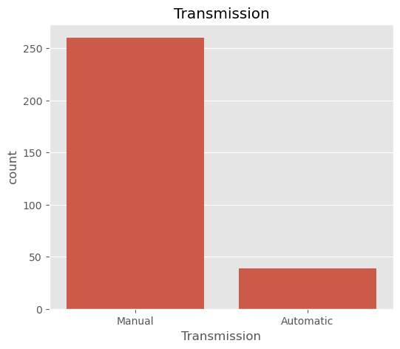
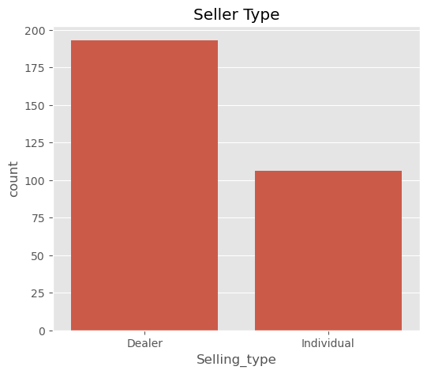
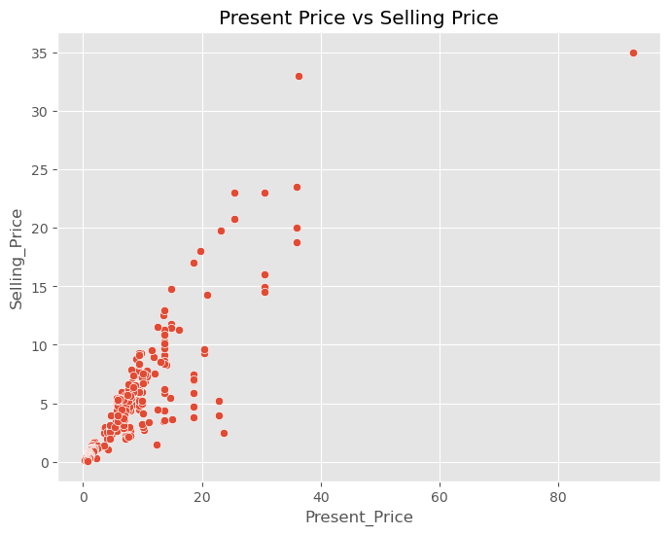
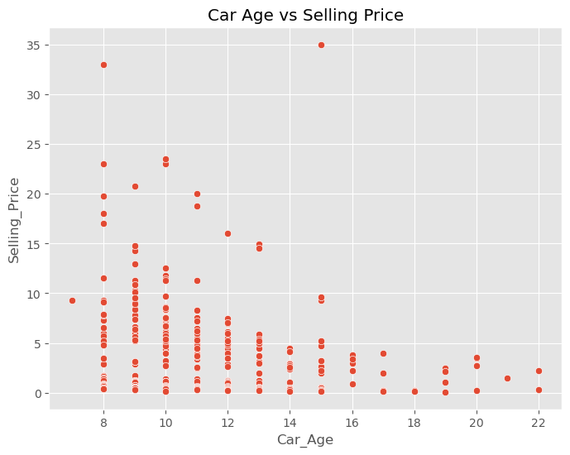
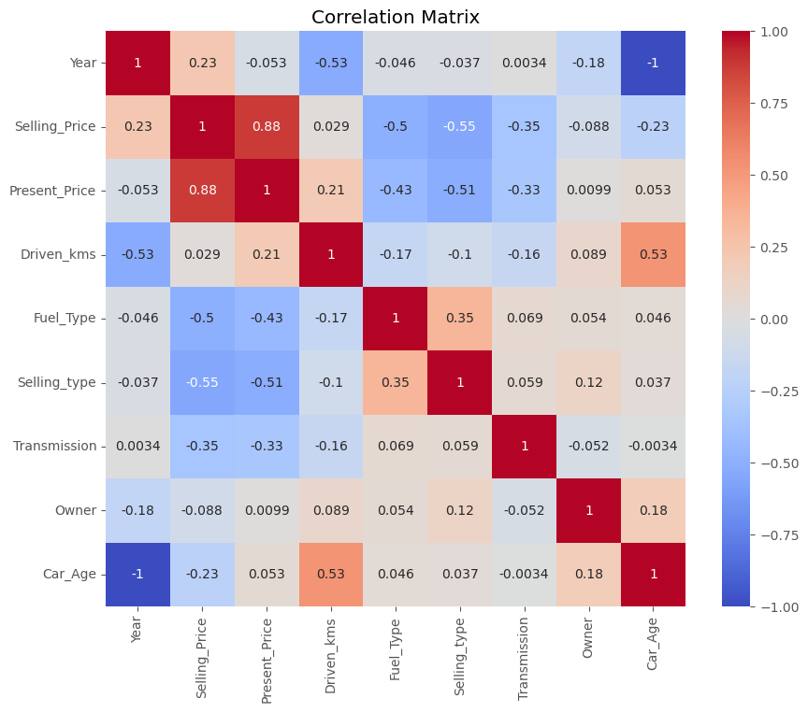

PART 1 COMPLETED

Feature Matrix Shape : (299, 8)
Target Shape : (299,)

Categorical Features
['Fuel_Type', 'Selling_type', 'Transmission']

Numerical Features
['Year', 'Present_Price', 'Driven_kms', 'Owner', 'Car_Age']

======================================================================
TRAIN TEST SPLIT
======================================================================
Training Samples : 239
Testing Samples : 60

Processed Training Shape : (239, 12)
Processed Testing Shape : (60, 12)

Number of Final Features : 12

First 15 Features
categorical__Fuel_Type_CNG
categorical__Fuel_Type_Diesel
categorical__Fuel_Type_Petrol
categorical__Selling_type_Dealer
categorical__Selling_type_Individual
categorical__Transmission_Automatic
categorical__Transmission_Manual
numerical__Year
numerical__Present_Price
numerical__Driven_kms
numerical__Owner
numerical__Car_Age

PART 2 COMPLETED SUCCESSFULLY

================================================================================
TRAINING MODELS
================================================================================

Random Forest
----------------------------------------
MAE : 1.5173
RMSE : 3.6451
R2 : 0.4845

Extra Trees
----------------------------------------
MAE : 1.0120
RMSE : 2.1499
R2 : 0.8207

Gradient Boosting
----------------------------------------
MAE : 1.1577
RMSE : 2.5493
R2 : 0.7478

================================================================================
MODEL COMPARISON
================================================================================
Model MAE RMSE R2 Score
0 Random Forest 1.517272 3.645074 0.484483
1 Extra Trees 1.011982 2.149932 0.820659
2 Gradient Boosting 1.157690 2.549267 0.747849

================================================================================
BEST MODEL
================================================================================
Best Model : Extra Trees
Best R2 Score : 0.8207

================================================================================
FINAL MODEL PERFORMANCE
================================================================================
Model : Extra Trees
MAE : 1.0120
RMSE : 2.1499
R2 : 0.8207

PART 3 COMPLETED SUCCESSFULLY

